Title: **Number Conversion, Math Functions and Logic Diagrams** Test: 6

Course: Introduction to Automation Unit: Introduction to PLC CLO: 4

Name ANSWER KEY Grade 30pts Date ______________

**Objectives**

1. Student shall calculate the correct number conversion base on a number from a different number base system.
2. Student shall draw the output of an instruction given its input(s).

**Assessment**

Students shall demonstrate a comprehension of the objectives listed above by scoring a minimum of 75% on this Test. Grading shall be based on the answer key.

**Instructions**

Calculate the following number to the new number base system given the value from another number base system.

|  |  |  |  |  |  |  |  |  |  |  |  |  |  |  |  |  |  |  |  |  |  |  |  |  |  |  |  |  |  |  |  |  |  |  |  |  |  |  |  |  |  |  |  |  |  |  |  |  |  |  |  |  |  |  |  |  |  |  |  |  |  |  |  |  |  |  |  |  |  |  |  |  |  |  |  |  |  |  |  |  |  |  |  |  |  |  |  |  |  |  |  |
| --- | --- | --- | --- | --- | --- | --- | --- | --- | --- | --- | --- | --- | --- | --- | --- | --- | --- | --- | --- | --- | --- | --- | --- | --- | --- | --- | --- | --- | --- | --- | --- | --- | --- | --- | --- | --- | --- | --- | --- | --- | --- | --- | --- | --- | --- | --- | --- | --- | --- | --- | --- | --- | --- | --- | --- | --- | --- | --- | --- | --- | --- | --- | --- | --- | --- | --- | --- | --- | --- | --- | --- | --- | --- | --- | --- | --- | --- | --- | --- | --- | --- | --- | --- | --- | --- | --- | --- | --- | --- | --- | --- |
| 1. 927410 1001 0010 0111 0100BCD 2. 561210 0101 0110 0001 0010BCD 3. 000111102 3010 4. 000010112 1110 5. 5610 0011 10002 6. 2310 0001 01112 7. 1011 10102 2728 8. 1001 00112 2238 | |  |  |  |  |  | | --- | --- | --- | --- | --- | | Truth Table | | | | | |  |  |  |  |  | |  |  |  |  |  | |  |  |  |  |  | |  |  |  |  |  | |  |  |  |  |  | |  |  |  |  |  | |  |  |  |  |  | |  |  |  |  |  | |  |  |  |  |  | |  |  |  |  |  | |  |  |  |  |  | |  |  |  |  |  | |  |  |  |  |  | |  |  |  |  |  | |  |  |  |  |  | |  |  |  |  |  | |  |  |  |  |  | |

|  |  |
| --- | --- |
| 1. 1238 0101 00112 | 1. 678 0011 01112 |
| 1. 238 1910 | 1. 588 N/A10 |
| 1. F2A416 1111 0010 1010 01002 | 1. E20C16 1110 0010 0000 11002 |
| 1. 1101 0001 1001 11102 D19E16 | 1. 1010 1011 1100 11012 ABCD16 |

Convert the following to the indicated number base.



1. Word 2BAD16
2. Byte 2558
3. Nibble 1310
4. Does this program have rung continuity? Why or why not? Explain in detail.

Yes, XIC I:0/0, XIO I:0/3, XIC I:0/5, XIC I:0/6 all have logical continuity.

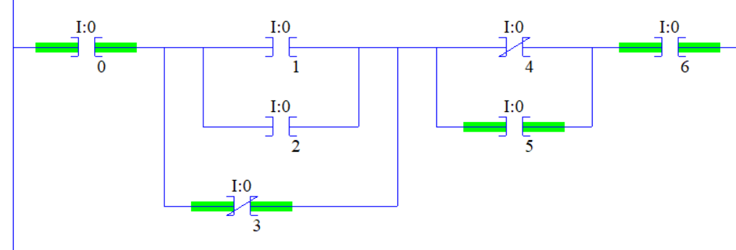

Select the best answer to each multiple-choice question below.

1. An ADD would be used to?
   1. Set a register based on the sum of two numbers
   2. Set a register based on the product of two numbers
   3. Set a register based on the difference of two numbers
   4. Set a register based on the dividend of two numbers
2. A SUB would be used to?
3. Set a register based on the sum of two numbers
4. Set a register based on the product of two numbers
5. Set a register based on the difference of two numbers
6. Set a register based on the dividend of two numbers
7. A DIV would be used to?
8. Set a register based on the sum of two numbers
9. Set a register based on the product of two numbers
10. Set a register based on the difference of two numbers
11. Set a register based on the dividend of two numbers
12. A MUL would be used to?
13. Set a register based on the sum of two numbers
14. Set a register based on the product of two numbers
15. Set a register based on the difference of two numbers
16. Set a register based on the dividend of two numbers
17. When a *motor timer* is done, half of the timer’s accumulative value needs to be stored in an integer register. Explain why the following code is not optimal.

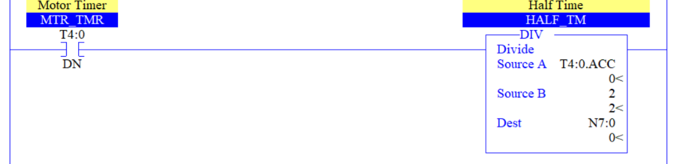

The divide function will be calculated thousands per second when it only needs to be performed once when the timer completes.

Draw the output to the following logic diagrams.







Draw a sealing start/stop manual motor control circuit using a NC pushbutton, a NO pushbutton, an eight-pin control relay, a green pilot light (running) and a red pilot light (stopped). Label all rungs, wires and terminals. Ensure to include contact cross-references. Control circuit shall be 24VDC and the Motor is 120VAC. (2 pts.)

